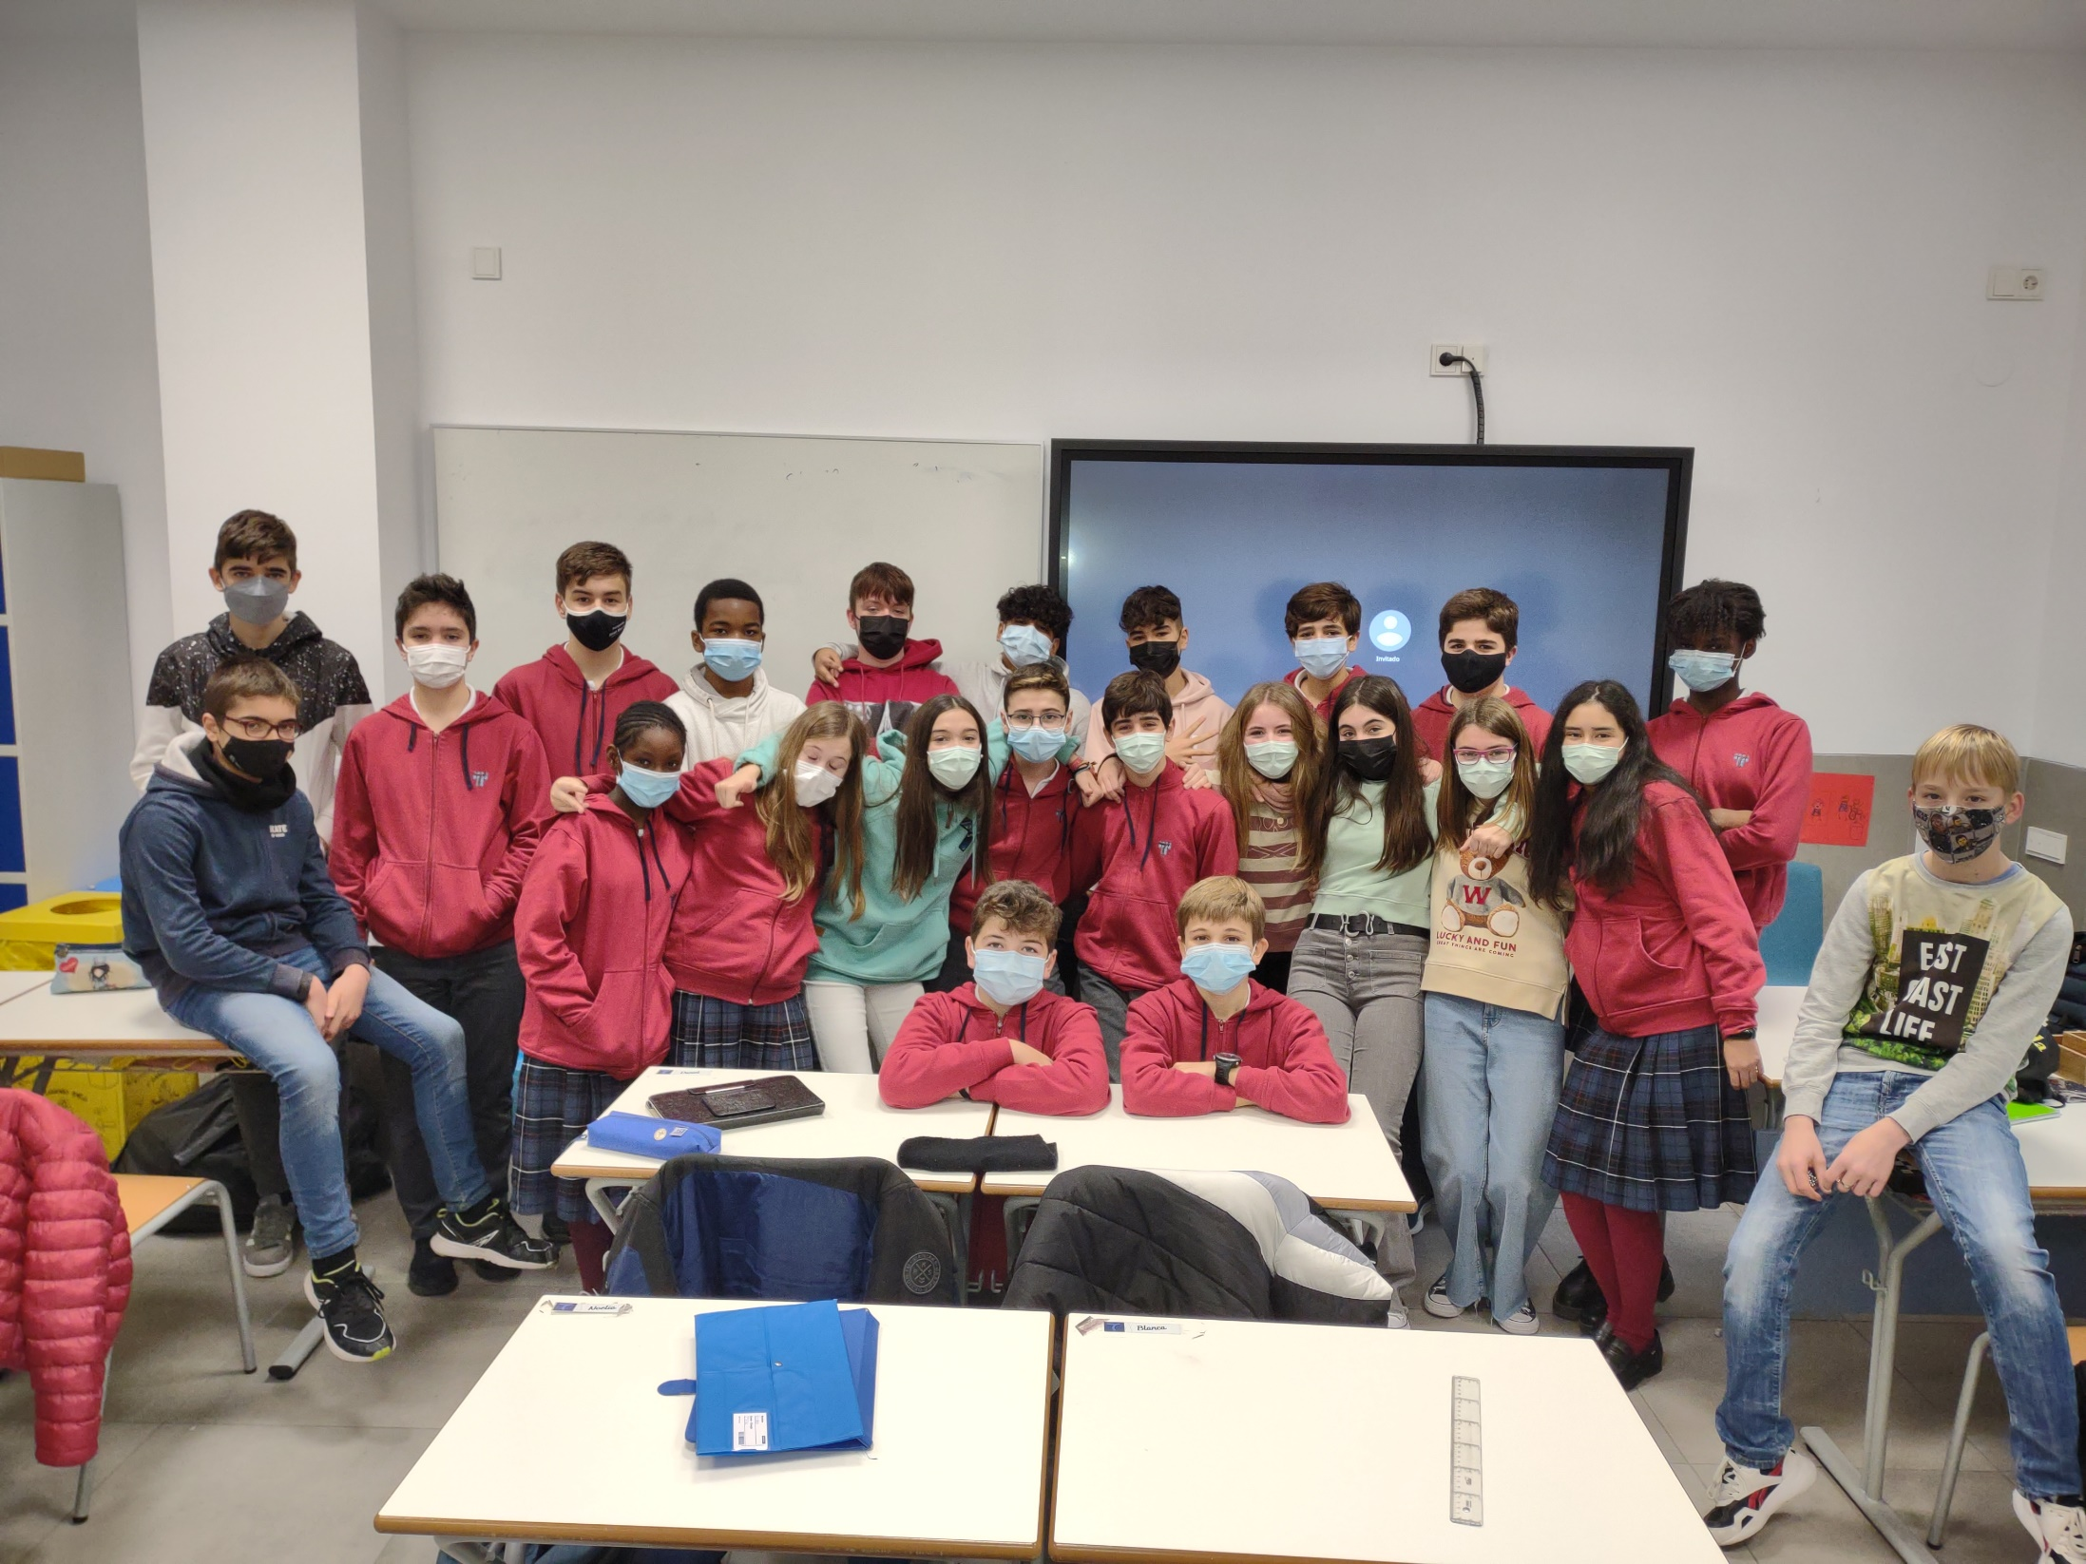­

**The 2nd Year Students want to wish you a Merry Christmas and a Happy 2022!!**